**Assignment I**

**Aayushi Sethi**

**BCA V sem**

**Cloud Computing**

**MKHS Gujarati Girls College Indore**

**Short answer type questions –**

**Q.1. What is Cloud Computing ?**

**Ans.**  Cloud computing refers to manipulating, configuring and accessing the hardware and software resources remotely. It offers online data storage, infrastructure and application. It is a technology that uses remote servers on the internet to store, manage, and access data online rather than local drives. The data can be anything such as files, images, documents, audio, video, and more.

**Q.2. Why is it called cloud computing?**

**Ans.**  A fundamental concept behind cloud computing is that the location of the service, and many of the details such as the hardware or operating system on which it is running, are largely irrelevant to the user. It's with this in mind that the metaphor of the cloud was borrowed from old telecoms network schematics, in which the public telephone network (and later the internet) was often represented as a cloud to denote that the just didn't matter -- it was just a cloud of stuff. This is an over-simplification of course; for many customers location of their services and data remains a key issue.

**Q.3. What is the history of cloud computing?**

**Ans.** Cloud computing as a term has been around since the early 2000s, but the concept of computing-as-a-service has been around for much, much longer -- as far back as the 1960s, when computer bureaus would allow companies to rent time on a mainframe, rather than have to buy one themselves.

These 'time-sharing' services were largely overtaken by the rise of the PC which made owning a computer much more affordable, and then in turn by the rise of corporate data centres where companies would store vast amounts of data.

**Q.4. Why Cloud Computing is important ?**

**Ans.** Small as well as large IT companies, follow the traditional methods to provide the IT infrastructure. That meansfor any IT company, we need a Server Room that is the basic need of IT companies.

In that server room, there should be a database server, mail server, networking, firewalls, routers, modem, switches, QPS (Query Per Second means how much queries or load will be handled by the server), configurable system, high net speed, and the maintenance engineers.

To establish such IT infrastructure, we need to spend lots of money. To overcome all these problems and to reduce the IT infrastructure cost, Cloud Computing comes into existence.

**Long answer type questions –**

**Q.1. What is cloud computing ? Write its importance ?**

**Ans**.The term **Cloud** refers to a **Network** or **Internet.** In other words, we can say that Cloud is something, which is present at remote location.

Cloud can provide services over public and private networks, i.e., WAN, LAN or VPN. Applications such as e-mail, web conferencing, customer relationship management (CRM) execute on cloud.

Cloud computing is the delivery of on-demand computing services -from applications to storage and processing power -- typically over the internet and on a pay-as-you-go basis.

Cloud Computing provides us means of accessing the applications as utilities over the Internet. It allows us to create, configure, and customize the applications online.

It is on demand delivery of IT resources through the Internet with payment depending on the use of the service is known as **cloud computing.**

It accesses the multiple server-based computer resources through a network. Cloud user accesses the server resources using the computer, smart phones, notebook, tablets or other devices.

Cloud server maintains all the processing and storage.

**Importance of Cloud Computing are –**

### Inexpensive

Cloud computing helps in reducing a considerable amount of CAPEX (Capital Expenditure) & OPEX (Operational Expenditures) an organization does not need to invest in expensive hardware’s, storage devices, & software’s etc. and you only have to pay for the resources you utilize.

**Elasticity & flexibility**

Cloud computing enables you to reduce and increase your resources demands as per your requirements. For e.g. if you have heavy traffic on your site you can increase your resources and vice versa. Cloud computing gives you the flexibility to work from wherever you want and whenever you want all you require is an internet connection.

**Auto Updating**

Software updates and upgrades can be a painful thing cloud computing simplifies it for you as all the software maintenance and upgrades are looked after and regulated by your cloud service provider.

**Increased collaboration**

Cloud computing enables employees to work in a more collaborative and coordinated manner as all the data and information about the organization, & ongoing projects is available to every employee and can be accessed from anywhere and anytime which helps in reducing delays and increase productivity.

### Cost Savings

There is a better use of server resources, which, once working together, allow the full use of memory, processing, disk space, etc.

### Speed

The more we enter the digital world, the more we realize that speed is critical for decision making, whether positive or negative. Everything in **[cloud computing](https://www.esds.co.in/enlight-cloud-hosting)** is connected and allows immediate interaction, changes are applied at the time sent and a better use of time is also felt.

**Q.2. Write Advantages and Disadvantages of Cloud Computing?­­**

**Ans**. **Advantages of Cloud Computing are –**

### Back-up and restore data

Once the data is stored in the cloud, it is easier to get back-up and restore that data using the cloud.

### Improved collaboration

Cloud applications improve collaboration by allowing groups of people to quickly and easily share information in the cloud via shared storage.

### Excellent accessibility

Cloud allows us to quickly and easily access store information anywhere, anytime in the whole world, using an internet connection. An internet cloud infrastructure increases organization productivity and efficiency by ensuring that our data is always accessible.

### Low maintenance cost

Cloud computing reduces both hardware and software maintenance costs for organizations.

### Mobility

Cloud computing allows us to easily access all cloud data via mobile.

### Services in the pay-per-use model

Cloud computing offers Application Programming Interfaces (APIs) to the users for access services on the cloud and pays the charges as per the usage of service.

### Unlimited storage capacity

Cloud offers us a huge amount of storing capacity for storing our important data such as documents, images, audio, video, etc. in one place.

### Data security

Data security is one of the biggest advantages of cloud computing. Cloud offers many advanced features related to security and ensures that data is securely stored and handled.

## Disadvantages of Cloud Computing are -

### Internet Connectivity

As you know, in cloud computing, every data (image, audio, video, etc.) is stored on the cloud, and we access these data through the cloud by using the internet connection. If you do not have good internet connectivity, you cannot access these data. However, we have no any other way to access data from the cloud.

### Vendor lock-in

Vendor lock-in is the biggest disadvantage of cloud computing. Organizations may face problems when transferring their services from one vendor to another. As different vendors provide different platforms, that can cause difficulty moving from one cloud to another.

### Limited Control

As we know, cloud infrastructure is completely owned, managed, and monitored by the service provider, so the cloud users have less control over the function and execution of services within a cloud infrastructure.

### Security

Although cloud service providers implement the best security standards to store important information. But, before adopting cloud technology, you should be aware that you will be sending all your organization's sensitive information to a third party, i.e., a cloud computing service provider. While sending the data on the cloud, there may be a chance that your organization's information is hacked by Hackers.

1. **Insecure or Incomplete Data Deletion**

It is possible that the data requested for deletion may not get deleted. It happens because either of the following reasons. Extra copies of data are stored but are not available at the time of deletion. Disk that stores data of multiple tenants is destroyed.

**Q.3. Explain characteristics of Cloud Computing ?­­**

**Ans**. **Characteristics of Cloud Computing are -**

1. **Agility**

The cloud **works in a distributed computing environment**. It shares resources among users and works very fast.

1. **High availability and reliability**

The availability of servers is high and more reliable because the chances of infrastructure failure are minimum.

1. **High Scalability**

Cloud offers **"**on-demand**"** provisioning of resources on a large scale, without having engineers for peak loads.

1. **Multi-Sharing**

With the help of cloud computing, multiple users and applications can work more efficiently with cost reductions by sharing common infrastructure.

1. **Device and Location Independence**

Cloud computing enables the users to access systems using a web browser regardless of their location or what device they use e.g. PC, mobile phone, etc. As infrastructure is off-site (typically provided by a third-party) and accessed via the Internet, users can connect from anywhere.

1. **Maintenance**

Maintenance of cloud computing applications is easier, since they do not need to be installed on each user's computer and can be accessed from different places. So, it reduces the cost also.

1. **Low Cost**

By using cloud computing, the cost will be reduced because to take the services of cloud computing, IT company need not to set itsown infrastructure and pay-as-per usage of resources.

1. **Services in the pay-per-use mode**

Application Programming Interfaces**(APIs)** are provided to the users so that they can access services on the cloud by using these APIs and pay the charges as per the usage of services.

**Q.4. Explain different technologies of cloud computing ?**

#### Ans. Different types of cloud computing technologies are -

#### Virtualization

It is the process of sharing license keys to physical instances of application among different users of the enterprise. The main purpose of this technology is to provide a standard version of the cloud application to all clients. It is popularly used for its flexibility and instant running process.

#### Service-Oriented Architecture

SOA is an application which divides the services into individual business functions and procedure daily. This unique component of cloud application enables cloud-related arrangements that can be modified and adjusted on request as business needs. Service-oriented system diffuses two major components, one is Quality as service and other as software as service. The function of Quality of service is to identify the function and behavior of a service from a different view. Software as a service provides a new delivery model of software which is inherited from the world of application service providers

#### Grid Computing

This is a process of connecting multiple servers from multiple to achieve a common goal. Grid computing turns large problems into smaller ones and broadcast to servers and place them within the grid. It is mainly applied in e-commerce and intended to share the resources on huge scale cluster computing.

#### Utility Computing

This process relies on the pay-per-utilize model. It gives computational services on demand for a metered benefit. It mainly helps in cost-cutting by reducing initial investment. As the computing requirements for a business change, the billing also changes accordingly, without acquiring any additional cost. If the client usage has decreased, then billing cost also reduces accordingly.

**Q.5. Describe the history of cloud computing ?**

**Ans.** Before emerging the cloud computing, there was Client/Server computing which is basically a centralized storage in which all the software applications, all the data and all the controls are resided on the server side.

If a single user wants to access specific data or run a program, he/she need to connect to the server and then gain appropriate access, and then he/she can do his/her business.

Then after, distributed computing came into picture, where all the computers are networked together and share their resources when needed.

On the basis of above computing, there was emerged of cloud computing concepts that later implemented.

At around in 1961, John MacCharty suggested in a speech at MIT that computing can be sold like a utility, just like a water or electricity. It was a brilliant idea, but like all brilliant ideas, it was ahead if its time, as for the next few decades, despite interest in the model, the technology simply was not ready for it.

But of course time has passed and the technology caught that idea and after few years we mentioned that:

In 1999, **Salesforce.com** started delivering of applications to users using a simple website. The applications were delivered to enterprises over the Internet, and this way the dream of computing sold as utility were true.

In 2002, **Amazon** started Amazon Web Services, providing services like storage, computation and even human intelligence. However, only starting with the launch of the Elastic Compute Cloud in 2006 a truly commercial service open to everybody existed.

In 2009, **Google Apps** also started to provide cloud computing enterprise applications.

Of course, all the big players are present in the cloud computing evolution, some were earlier, some were later. In 2009, **Microsoft** launched Windows Azure, and companies like Oracle and HP have all joined the game. This proves that today, cloud computing has become mainstream.

**Assignment II**

**Q.1. Explain Types of Cloud Computing?**

**Ans.**

**Public Cloud**

A public cloud environment is owned by an outsourced cloud provider and is accessible to many businesses through the internet on a pay-per-use model. This deployment model provides services and infrastructure to businesses who want to save money on IT operational costs, but it’s the cloud provider who is responsible for the creation and maintenance of the resources.

Public clouds are ideal for small and medium sized businesses with a tight budget requiring a quick and easy platform in which to deploy IT resources.

****Pros of a public cloud****

* Easy scalability
* No geographical restrictions
* Cost effective
* Highly reliable
* Easy to manage

****Cons of a public cloud****

* Not considered the safest option for sensitive data

## Private Cloud

## This cloud deployment model is a bespoke infrastructure owned by a single business. It offers a more controlled environment in which access to IT resources is more centralised within the business. This model can be externally hosted or can be managed in-house. Although private cloud hosting can be expensive, for larger businesses it can offer a higher level of security and more autonomy to customise the storage, networking and compute components to suit their IT requirements.

****Pros of a private cloud****

* Improved level of security
* Greater control over the server
* Customisable

****Cons of a private cloud****

* Harder to access data from remote locations
* Requires IT expertise

**Hybrid Cloud**

For businesses seeking the benefits of both private and public cloud deployment models, a hybrid cloud environment is a good option. By combining the two models, a hybrid cloud model provides a more tailored IT solution that meets specific business requirements.

****Pros of a hybrid cloud****

* Highly flexible and scalable
* Cost effective
* Enhanced security

****Cons of a hybrid cloud****

* Communication in network level may be conflicted as it’s used in both private and public clouds.

**Q.2. Explain Cloud Computing Architecture ?**

**Ans.** Cloud computing architecture is a combination of **service-oriented architecture** and **event-driven architecture**.

Cloud computing architecture is divided into the following two parts -

### **Front End**

The front end is used by the client. It contains client-side interfaces and applications that are required to access the cloud computing platforms. The front end includes web browsers (including Chrome, Firefox, internet explorer, etc.), thin & fat clients, tablets, and mobile devices.

### **Back End**

The back end is used by the service provider. It manages all the resources that are required to provide cloud computing services. It includes a huge amount of data storage, security mechanism, virtual machines, deploying models, servers, traffic control mechanisms, etc.

#### Note: Both front end and back end are connected to others through a network, generally using the internet connection.

## **Components of Cloud Computing Architecture**

There are the following components of cloud computing architecture -

**1. Client Infrastructure**

Client Infrastructure is a Front end component. It provides GUI (Graphical User Interface)  to interact with the cloud.

**2. Application**

The application may be any software or platform that a client wants to access.

**3. Service**

A Cloud Services manages that which type of service you access according to the client’s requirement.

**4. Runtime Cloud**

Runtime Cloud provides the **execution and runtime environment** to the virtual machines.

**5. Storage**

Storage is one of the most important components of cloud computing. It provides a huge amount of storage capacity in the cloud to store and manage data.

**6. Infrastructure**

It provides services on the **host level**, **application level**, and **network level**. Cloud infrastructure includes hardware and software components such as servers, storage, network devices, virtualization software, and other storage resources that are needed to support the cloud computing model.

**7. Management**

Management is used to manage components such as application, service, runtime cloud, storage, infrastructure, and other security issues in the backend and establish coordination between them.

**8. Security**

Security is an in-built back end component of cloud computing. It implements a security mechanism in the back end.

**9. Internet/Network**

The Internet is medium through which front end and back end can interact and communicate with each other.

**Q.3. Explain Cloud Service Models ?**

**Ans.** Service Models

Cloud computing is based on service models. These are categorized into 4 basic service models which are -

* Infrastructure-as–a-Service (IaaS)
* Platform-as-a-Service (PaaS)
* Software-as-a-Service (SaaS)
* Network as–a –services

**Anything-as-a-Service (XaaS)**  **:** is yet another service model, which includes , Business-as-a-Service, Identity-as-a-Service, Database-as-a-Service or Strategy-as-a-Service.

The **Infrastructure-as-a-Service (IaaS) :**  is the most basic level of service. Each of the service models inherit the security and management mechanism from the underlying model, as shown in the following diagram:

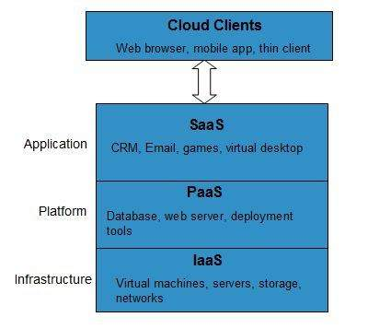

**IaaS** provides access to fundamental resources such as physical machines, virtual machines, virtual storage, etc.

**Platform-as-a-Service (PaaS)**

**PaaS** provides the runtime environment for applications, development and deployment tools, etc.

Software-as-a-Service (SaaS)

**SaaS** model allows to use software applications as a service to end-users.

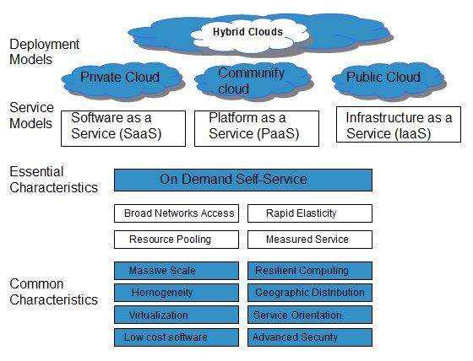

**Q.4. Explain Cloud Deployment Model ?**

**Ans.**

Deployment models define the type of access to the cloud, i.e., how the cloud is located? Cloud can have any of the four types of access: Public, Private, Hybrid, and Community.

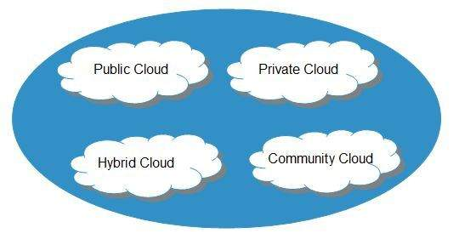

**Public Cloud**

The **public cloud** allows systems and services to be easily accessible to the general public. Public cloud may be less secure because of its openness.

**Private Cloud**

The **private cloud** allows systems and services to be accessible within an organization. It is more secured because of its private nature.

**Community Cloud**

The **community cloud** allows systems and services to be accessible by a group of organizations.

**Hybrid Cloud**

The **hybrid cloud** is a mixture of public and private cloud, in which the critical activities are performed using private cloud while the non-critical activities are performed using public cloud.

**Q5. Explain Cloud InfraStructre ?**

**Ans. Cloud infrastructure** consists of servers, storage devices, network, cloud management software, deployment software, and platform virtualization.

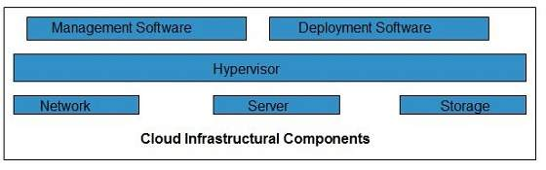

**Hypervisor**

**Hypervisor** is a **firmware** or **low-level program** that acts as a Virtual Machine Manager. It allows to share the single physical instance of cloud resources between several tenants/ clients.

**Management Software**

It helps to maintain and configure the infrastructure.

**Deployment Software**

It helps to deploy(to give) and integrate the application on the cloud.

**Network**

It is the key component of cloud infrastructure. It allows to connect cloud services over the Internet. It is also possible to deliver network as a utility over the Internet, which means, the customer can customize the network route and protocol.

**Server**

The **server** helps to compute the resource sharing and offers other services such as resource allocation and de-allocation, monitoring the resources, providing security etc.

**Storage**

Cloud keeps multiple replicas of storage. If one of the storage resources fails, then it can be extracted from another one, which makes cloud computing more reliable.